Chapter 9, Solution 84.

Let 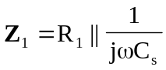, 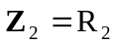, 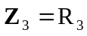, and 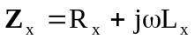.
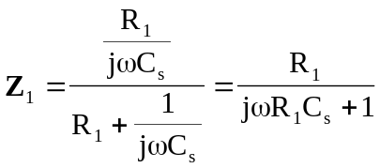

Since 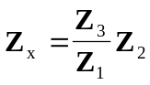,
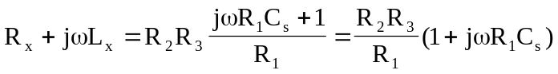

Equating the real and imaginary components,
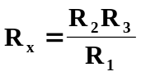

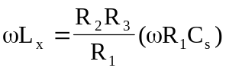 implies that
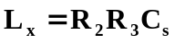

Given that 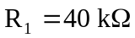, 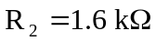, 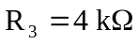, and 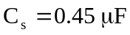

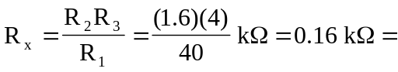 160 
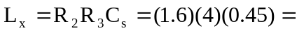 2.88 H

